# CS 255 System Design Document Template

Kevin Romero

## UML Diagrams

### UML Use Case Diagram

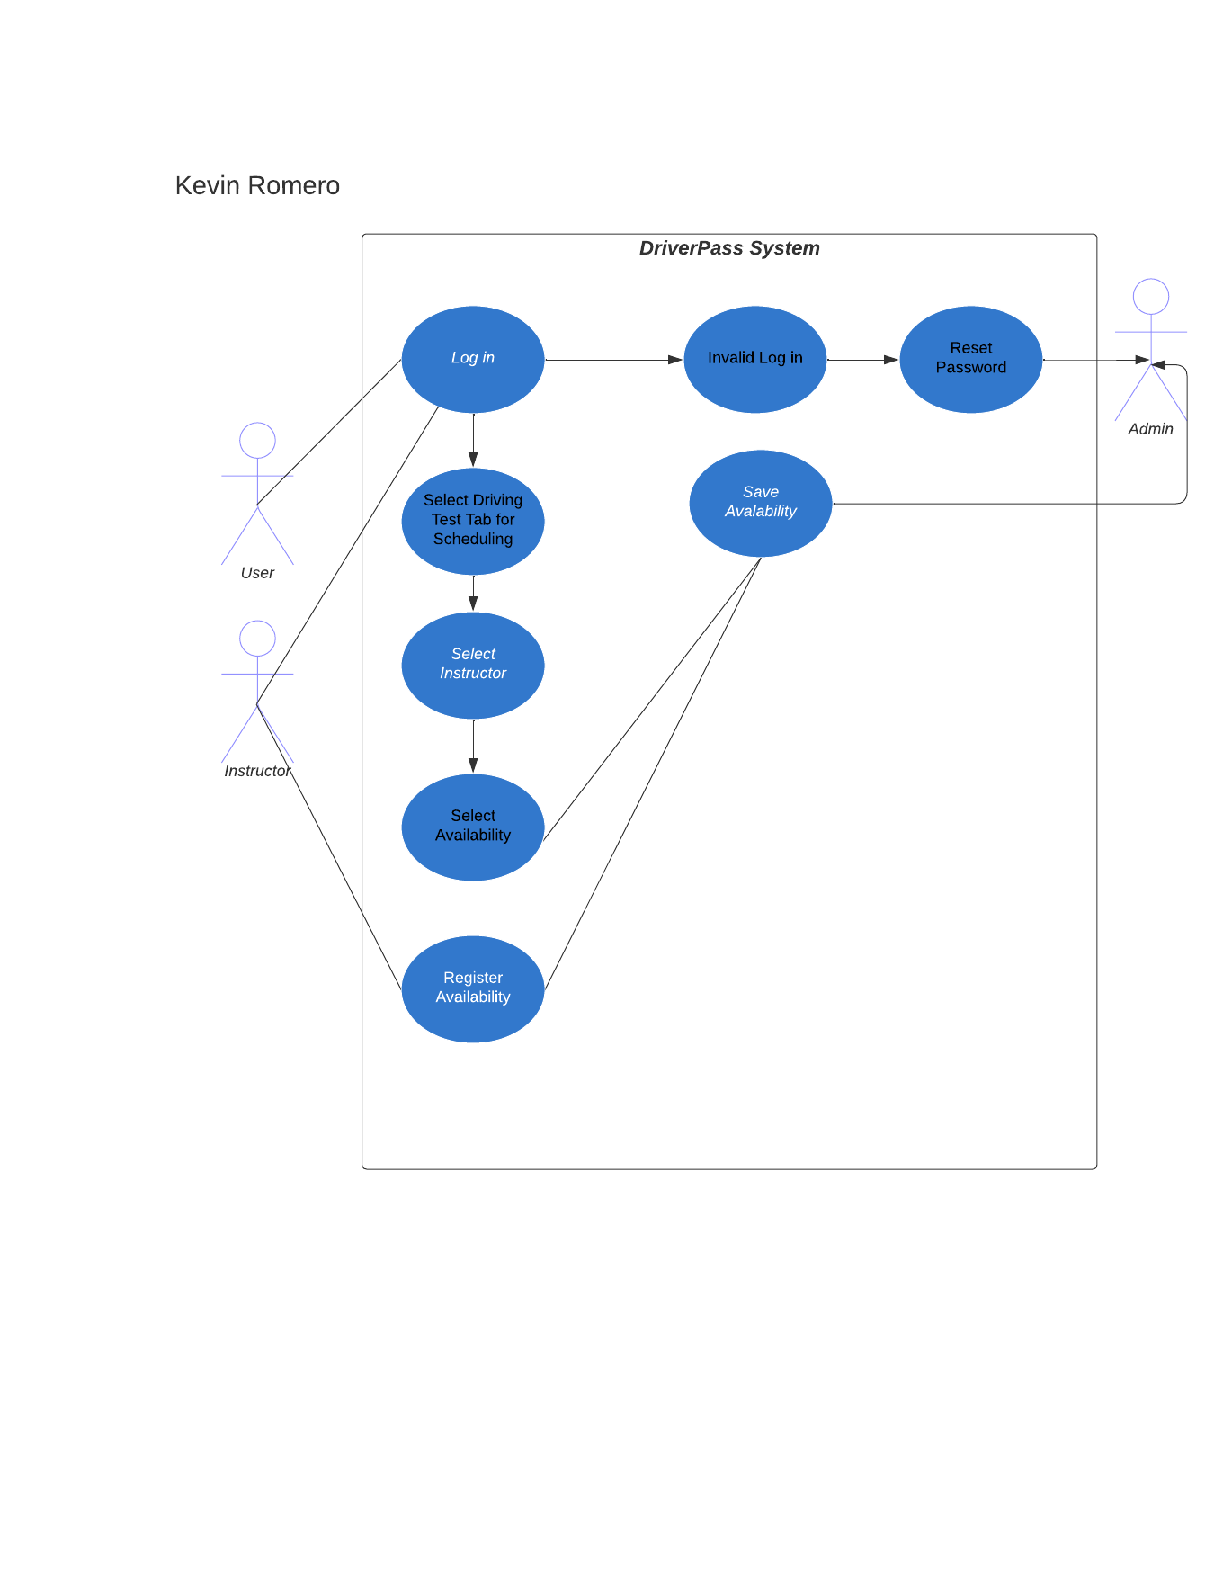

### UML Activity Diagrams

1. 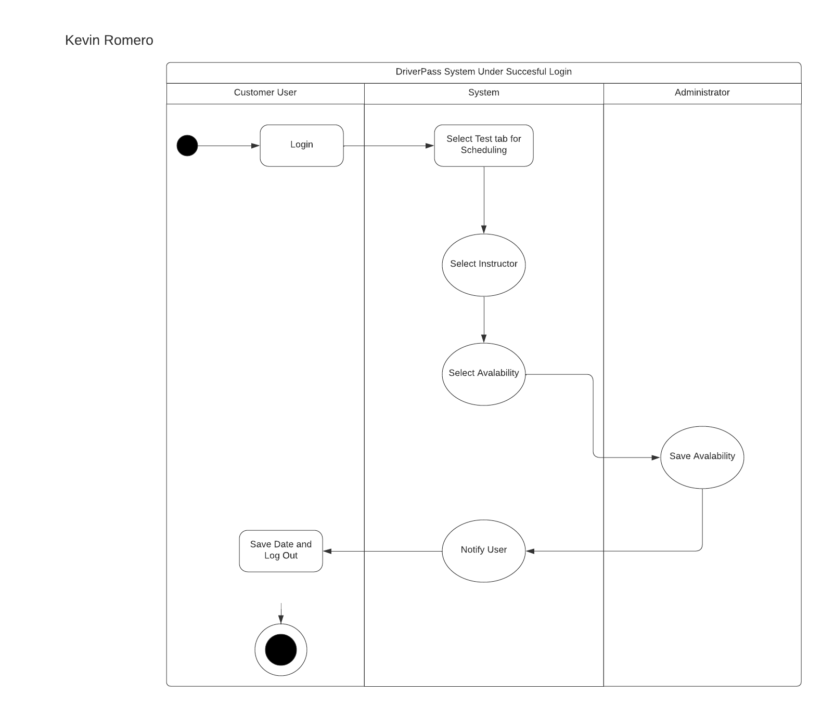
2. 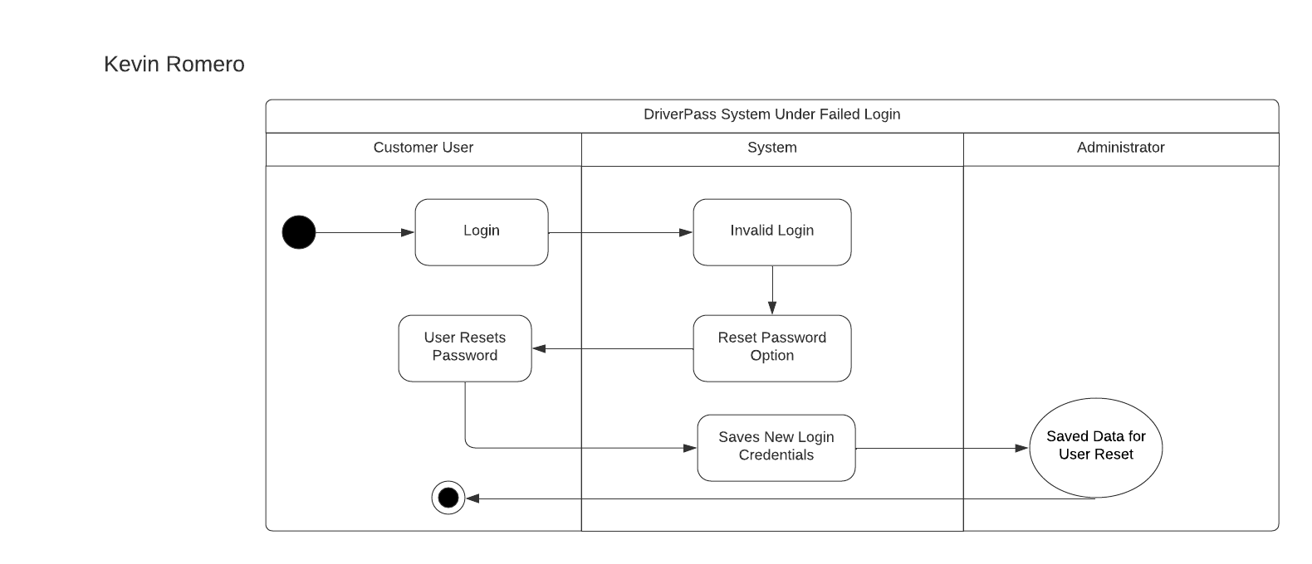

### UML Sequence Diagram

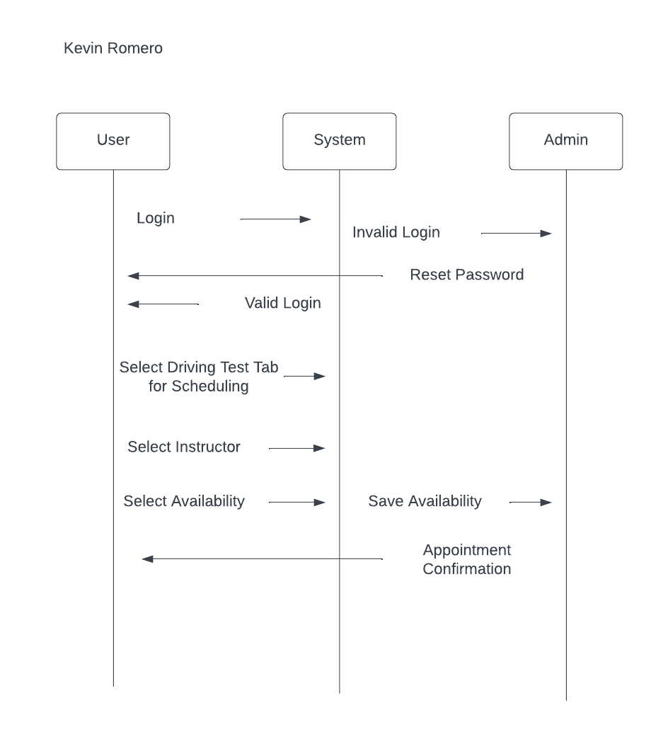

### UML Class Diagram

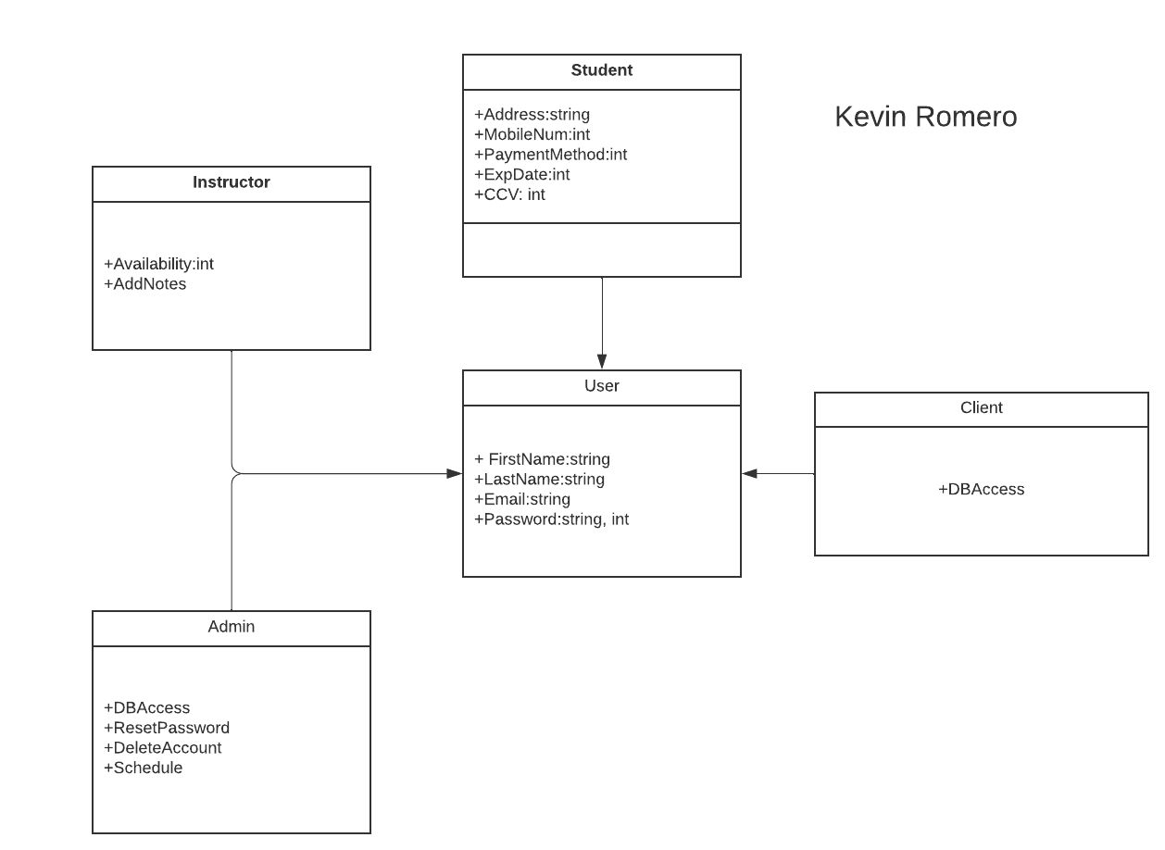

## Technical Requirements

This system should run on a native website and also a mobile application. In order for the user to make use of the service, the user will need to have a device that can connect to the internet and also be able to load the website or application. As developers we will need developing software to be able to build the system, tools such as Eclipse can be used to develop the site and Swift for developing on mobile, especially iOS devices. We will need a database in order to be able to store our data so the client can access it and so the users do not run into data loss or replication issues. In order to solve this, we can set up our own infrastructure to host the data otherwise we can opt for a simpler, more efficient option such as a provider like AWS.